1. ~~Main Menu Logo Background and frame position.**Done**~~

Ref: http://preview.themeforest.net/item/emilus-react-admin-template/full_screen_preview/28400277?_ga=2.23975866.1636690533.1679452249-489259943.1679452249&_gac=1.151200331.1679452249.CjwKCAjwq-WgBhBMEiwAzKSH6D2UHnv1AijWaIVqg8CkGgkLhfF73qX5iXaSu8VLoU0IgKxmLHFdLBoCJrwQAvD_BwE

1. ~~Change expands icon & add site description name**Done**~~

1. Evantage Main Menu Logo on Top

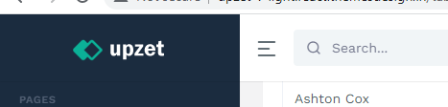

1. ~~Click Left Menu no need to animate. **Done**~~

1. ~~icon on module expand.**Done**~~

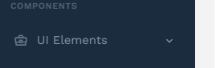

When default facing down

When expend > facing top

1. ~~Allign word to same position**Done**~~

~~7. change Font colour (default grey highlight white)**Done**~~

~~8. Menu Font Size change smaller**Done**~~

<http://upzet-v-light.react.themesdesign.in/table-datatable>

<http://preview.themeforest.net/item/emilus-react-admin-template/full_screen_preview/28400277?_ga=2.23975866.1636690533.1679452249-489259943.1679452249&_gac=1.151200331.1679452249.CjwKCAjwq-WgBhBMEiwAzKSH6D2UHnv1AijWaIVqg8CkGgkLhfF73qX5iXaSu8VLoU0IgKxmLHFdLBoCJrwQAvD_BwE>

<https://isomorphic.redq.io/dashboard/my-profile>

~~9. Navbar / Sidebar underline**Done**~~

~~10. All word same Font size**Done**~~

~~11. Word color grey to white**Done**~~

12. Navbar Open and Close > Sidebar Logo

~~13. Site_cd – passing API to Navbar page **Done**~~